Reflections, a public design assignment in Haninge, Sweden, June 2024
By Susan Whitlow, Hanna Rubin och Lotta Wästerlid Zmuda-Trzebiatowski

Together witg two other artist I was asked to give a place called Cykelstället in a Eskilsparken in Haninge a new form and appearance. Cykelstället was once bulit to make foreign people learn how to ride a bike. We decided to make one piece each and then do the outside together and with inspiration from kids. We arranged a workshop where we printed with parts from bikes such as the chain and the bell and from that we could make a shape that we then printed on the outside.

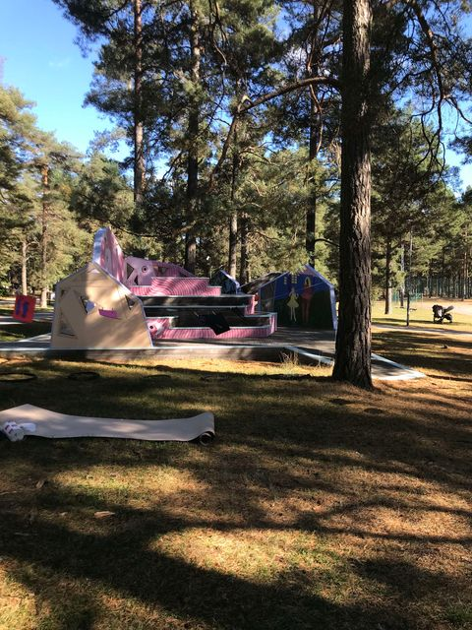

I did three parts on my own. Based on the reflection of imagined kids playing in the park It was large surface of around 3 x 3 m, and 1,5 x 1,5 m. Together we did the workshops and the process of getting the image when then transformed to around 14 surfaces.

My work:

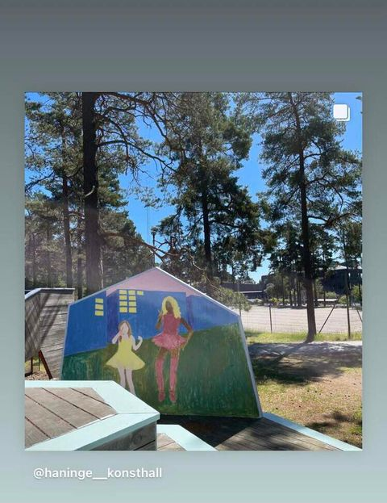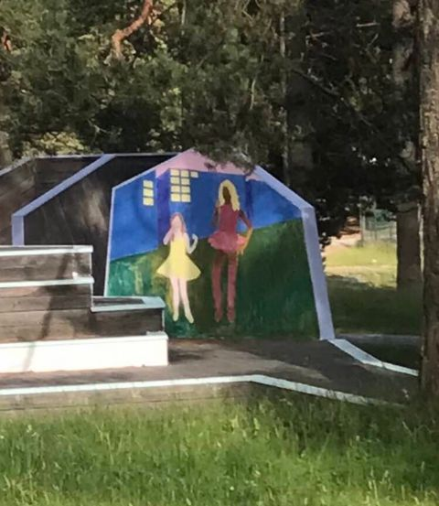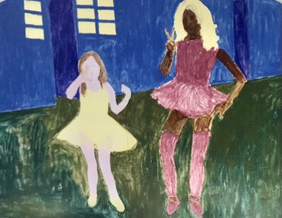

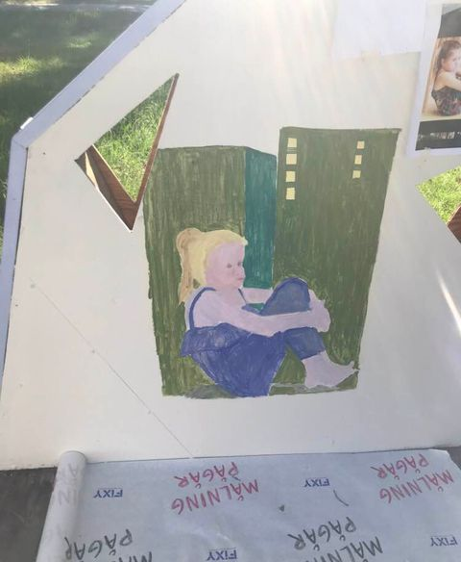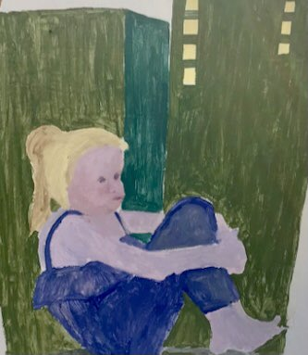

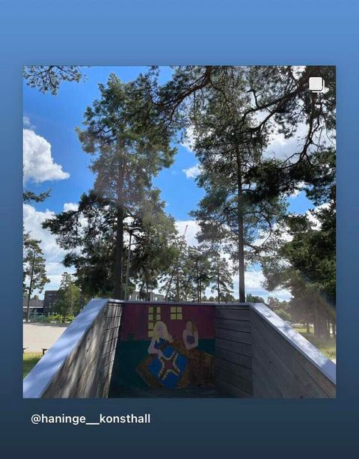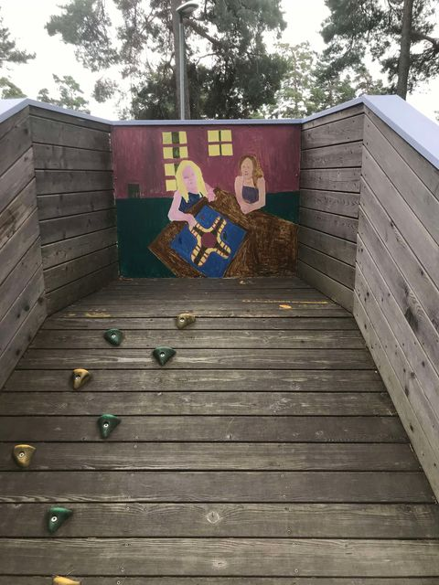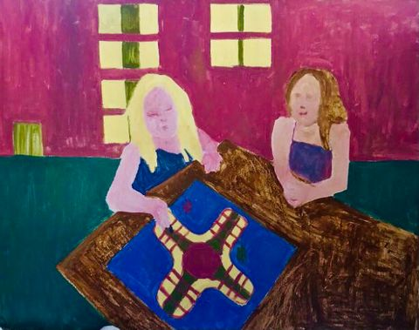

Workshops and Colloboration

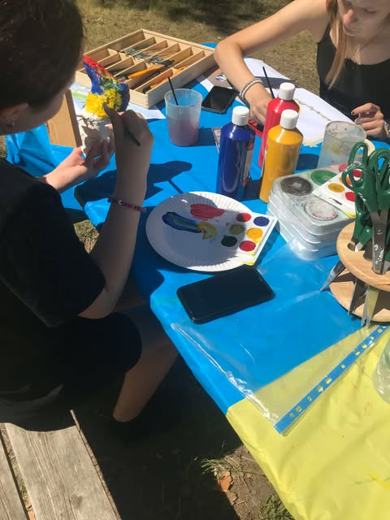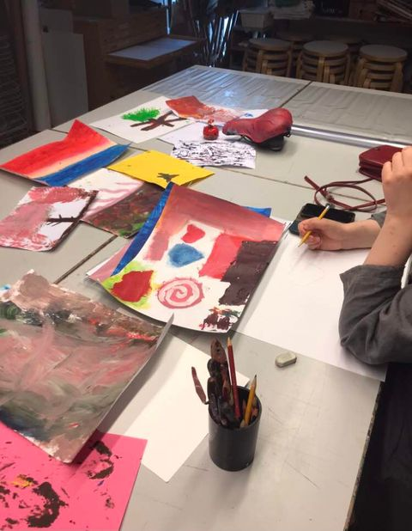

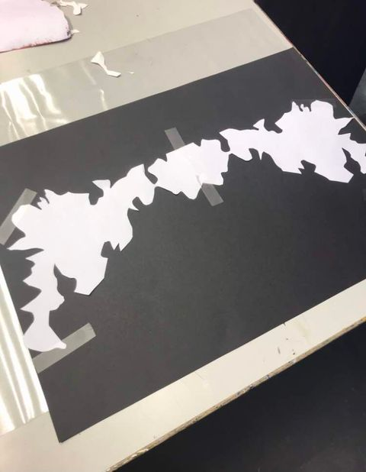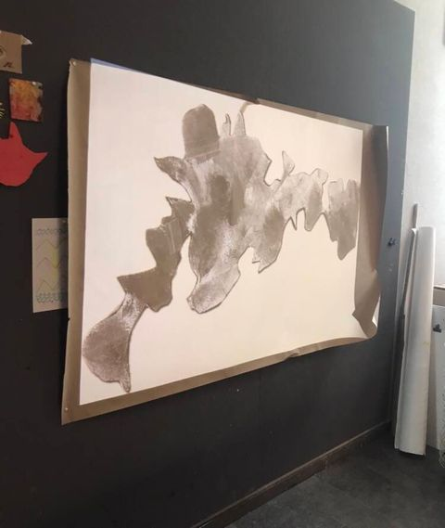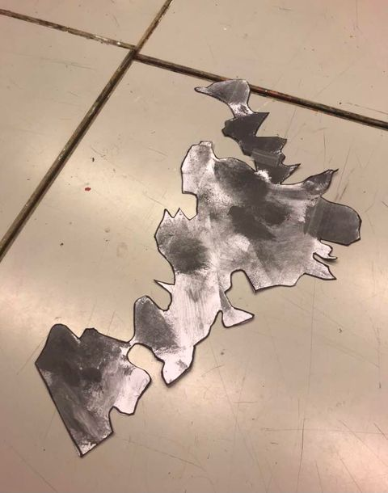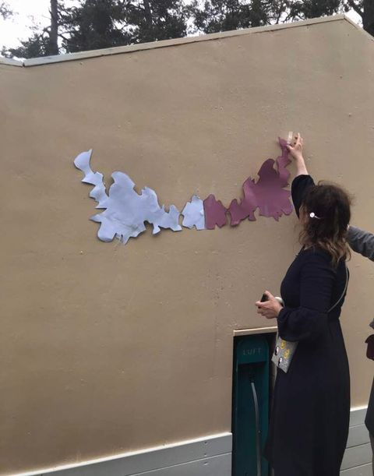

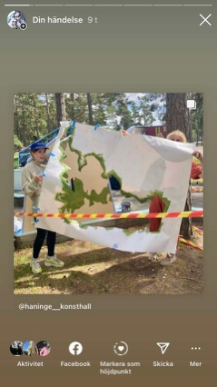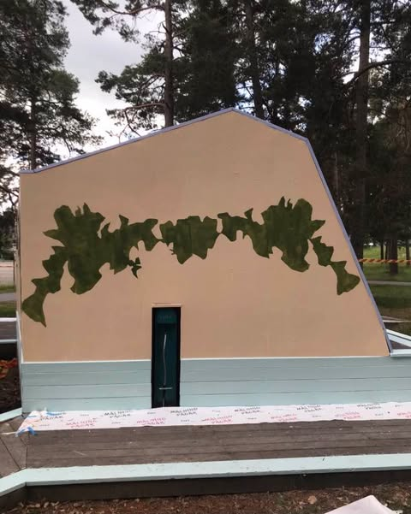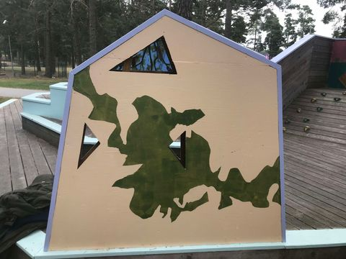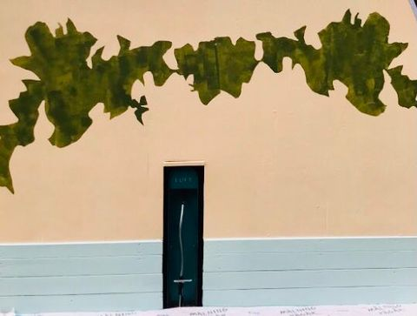

Inaguration, sep 2024:

